**巴拿马设立全球首家“区块链使馆”**

编辑：徐雪 2017.9.11

*“兼具学习交流与娱乐功能，该区块链使馆尽其所能满足爱好者需求，尽最大努力让更多的人了解区块链知识”*

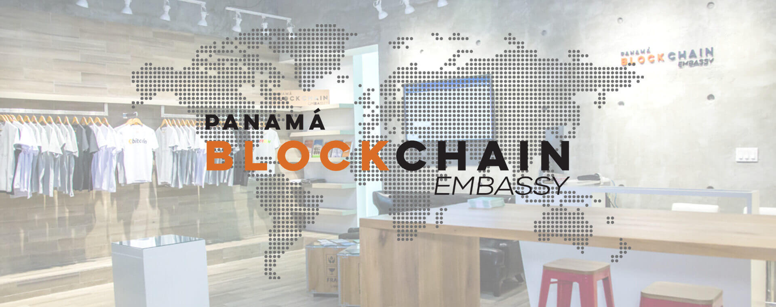

近日，巴拿马为大众，尤其是加密数字货币爱好者和行家等提供了一个新去处，即“区块链使馆（Embassy ）“。该使馆主要为了传播区块链知识，并且为大家提供区块链技术和加密货币相关知识和实验交流与分享的场所。使馆坐落于巴拿马城巴尔博亚大道巴尔博亚精品购物中心，里面有加密货币ATM机，一个展示厅，也销售一些主流品牌的硬件钱包，T恤，咖啡杯，Real币以及其他的一些纪念品。

此外，使馆里面还有个咖啡厅，也有啤酒，还有公共办公区以及显示着不同加密货币的实时报价的多功能显示屏，此外还设立阅读区并且销售区块链相关书籍。另外，使馆内设有不同阶段的培训课程项目，主要为了能够向大众传递区块链技术相关知识。

该区块链使馆是初创公司Cryptobuyer.io推出的项目之一，他们是全球首家在多个商业银行安装ATM和Cryptobuyer系统的公司，该系统可以支持比特币和其他货币付款。使馆提供现金支付和加密货币支付，已经成为巴拿马地区标志性的旅游景点，也吸引了世界各地的游客。

标签：区块链使馆；加密货币

总浏览数：***

*【声明：文章为作者独立观点，不代表UNITIMES官网立场。欢迎转载，转载请务必注明来源。如有不当之处请多指教】*

**New Blockchain Embassy Opens in Panama**

Editor: Xue Xu 11Sept, 2017

*“The Blockchain Embassy functions not only as a place for technology fans, but also for developers to share and communicate views and researches on this space.* You can also enjoy talking over a cup of coffee or beer as it provides cafeteria service.*.”*



Panama has opened a newly built“Blockchain Embassy” for general public in the prestigious Balboa Boutiques Strip Mall of Balboa Avenue in Panama City. It is especially a good place for Blockchain fans and experts to share, communicate and learn about blockchain technology and cryptocurrencies in general. It has a Crypto ATM, an exhibition and sale of the main brands of Hardware Wallets, T-Shirts, Coffee Mugs, Real Coins and others Souvenirs, etc.

The Embassy provides educational courses at different levels， aiming at bringing the technology to the general public. You can also enjoy talking with friends over a cup of coffee or beer as it provides cafeteria service. The multiple screens showing the real-time quote of various active crypto currencies, and it also has open working space and reading area. If you want Blockchain related books, then it’s the right place for you.

The Embassy accepts payments in cash and Crypto currencies, and it has become an attractive tourist site for people worldwide. The Embassy is one of the projects launched by a Start Up Cryptobuyer.io, and it is the first in the world in installing ATMs and Cryptobuyer system in commercial banks which can support payments in Bitcoin and other currencies.

Tags：Blockchain embassy: Cryptocurrency

Total views：***

*【Declaration: Please indicate the source if repost the article in UNITIMES. Opinions expressed by Contributors belong to themselves.】*